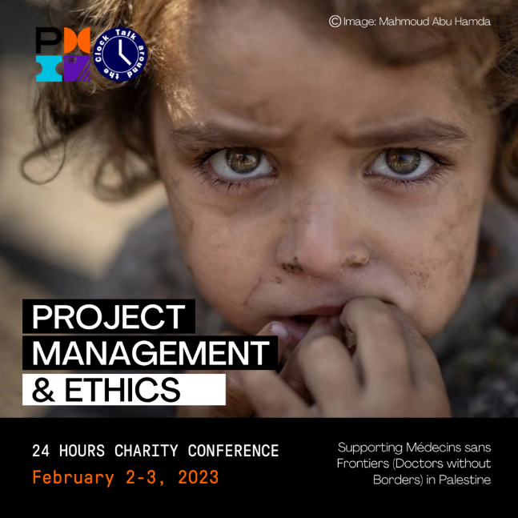
FOR IMMEDIATE RELEASE

PMI Sweden Chapter Presents 3rd Talk Around the Clock Virtual Charity Congress
4th January 2023

Project Management and Ethics
Stockholm: PMI Sweden Chapter Presents 3rd Talk Around the Clock, a 24-hour Virtual Charity Conference
PMI Sweden Chapter, a non-profit member organisation for project, program, and portfolio managers, is pleased to announce a global virtual conference, Talk Around the Clock, set to take place on 2-3 February 2024. This Talk Around the Clock follows the tradition of two extraordinary events from 2022 and 2023: Leading project management experts and trainers from around the world speak pro-bono to help Médecins Sans Frontières (Doctors Without Borders) bring life-saving medical care and supplies to war victims in Palestine.
PMI Sweden Chapter envisions the 3rd Talk Around the Talk as an opportunity to bring together the global project management community for 24 hours to learn from experts about ethics in project management as well as an opportunity to make a difference in times of need.
“In these times of urgent need to support the war victims in Palestine, we wanted to do what we can”, says Katarina Strömberg, President of the PMI Sweden Chapter. “We initiated this 24-hours conference to raise funds, but also to let our community get together, share, learn and discuss. We urge both individuals and companies to take this opportunity to develop competence and at the same time contribute to fellow humans in need.”
All revenue from the conference will be donated to Médecins Sans Frontières (Doctors Without Borders). The conference is sponsored by the PMI Sweden Chapter and Oliver F. Lehman and organised by volunteers from various PMI chapters. Volunteers and speakers are committed to the calls of Médecins Sans Frontières for immediate and permanent ceasefire to end the devastating loss of life and suffering, particularly of the children in Palestine.
“The Gaza Strip is the most dangerous place in the world to be a child. And day after day, that brutal reality is reinforced.” UNICEF Spokesperson James Elder
Registration for Talk Around the Clock: Project Management and Ethics is now open through the official event website: https://talk-around-the-clock.com/donate-reserve-seat
For media inquiries or to request press passes, please contact:
Katarina Korenkova,
Communications Manager – Talk Around the Clock
Vice President South Branch – PMI Sweden Chapter
Email: katarina.korenkova@pmi-se.org
www.pmi-se.org

